|  |
| --- |
|  |
| 新概念 3 册 |
| Lesson32 |

Lesson 32 A lost ship

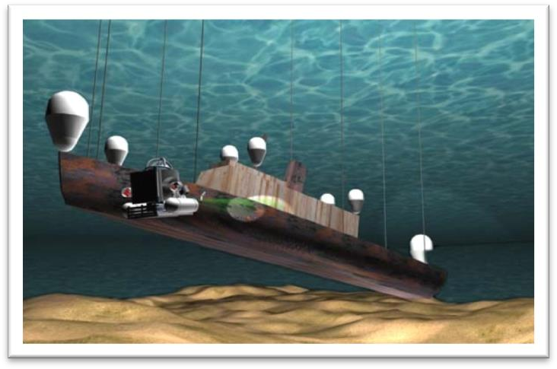

**salvage ['sælvɪdʒ]**

**v. 营救，拯救，打捞**

salvage

He tried desperately to salvage belongings from the burning house. save / rescue

When you rescued your trousers, did you find the note was whiter than white?

When a passing tanker rescued them five days later, both men were genuinely sorry that they had to leave.

pick sb. up

The 'Antoinette' floated on the water until Latham was picked up by a ship.

sunken ['sʌŋkən] adj. 沉没的

sunken treasure a sunken ship The ship was sunken. X

The ship has sunk / has been sunk. √ her sunken eyes / cheeks unsinkable

At that time, however, she was not only the largest ship that had ever been built, but was regarded as unsinkable, for she had 16 watertight compartments.

scour ['skaʊə(r)]

**v. 彻底搜索**

search (a place) for ...

The detective is searching for clues.

The small ship, Elkor, which had been searching the Barents Sea for weeks, was on its way home. hunt for ...

I’m hunting for a job now.

The hunt for the puma began in a small village where a woman picking blackberries saw 'a large cat' only five yards away from her.

fumble for ...

She fumbled for her keys in her purse.

If you are lucky enough to get a sleeper, you spend half the night staring at the small blue light in the ceiling, or fumbling to find your ticket for inspection.

scour a place for ...

The sea bed was scoured with powerful nets ... comb a place for ...

The police are combing the woods for the fugitive.

chest [tʃest]

**n. 大箱子**

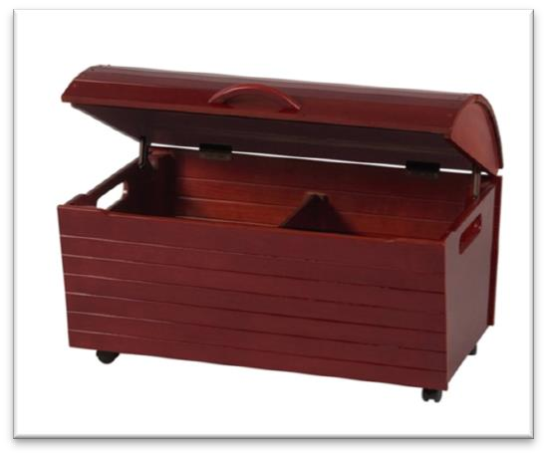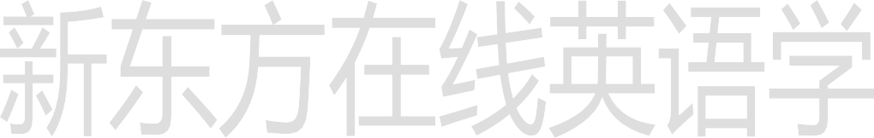**chest cardboard box**

**packing case suitcase**

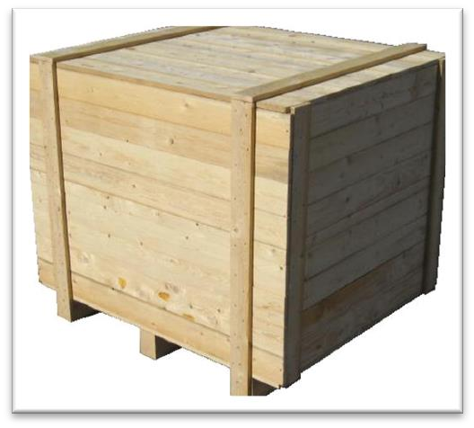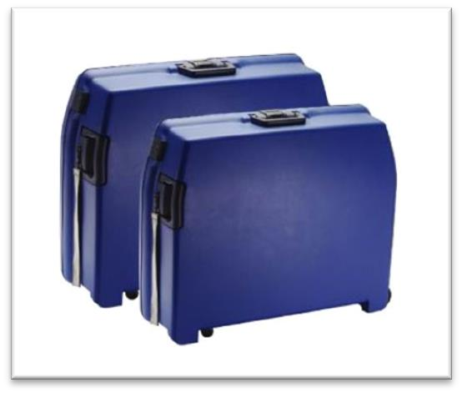

**boot / trunk money box / piggy bank**

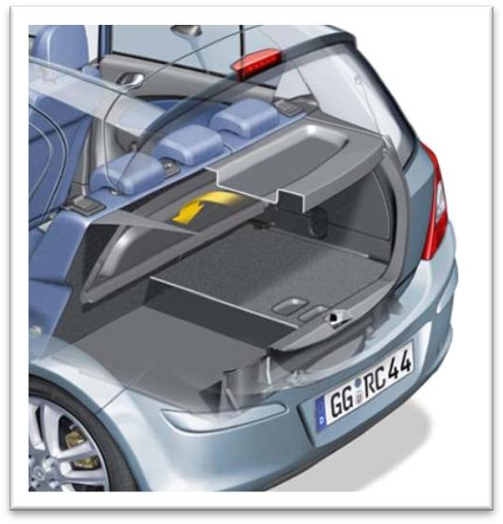 

belongings [bɪ'lɒŋɪŋz]

**n. 财产，动产，所有物**

belongings / things

He told me to unpack my things and then come down to dinner. property / real estate

the property market real estate agent possessions / property

People tend to amass possessions, sometimes without being aware of doing so. assets

liquid / fixed / tangible / intangible assets

cruiser ['kru:zə(r)]

**n. 巡洋舰**

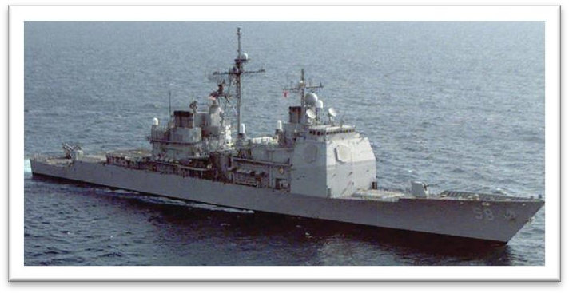**cruiser**

“cru” = cross

cruise crucial crusade a crusade against official corruption

find [faɪnd]

**n. 被找到的人或物**

My new secretary is a real find.

I made a great find in a second-hand bookstore. buy / bargain

Oh my! Here’s a real buy. It’s a bargain. This house just came on the market. must

Move to a cheaper apartment.

Find a person to share their apartment.

Hire a new worker.

Write an accurate description of a friend.

W1: What we need is a roommate who is neat and considerate. W2: Let’s write that in the ad: neat-ness and consideration a must. What do the speakers hope to do?

Answer: (B) Find a person to share their apartment.

naval ['neɪvl] adj. 海军的

navy land force air force nav / nau = ship navigation

nausea nauseate

nautical nautical chart nautical mile aeronautics astronautics

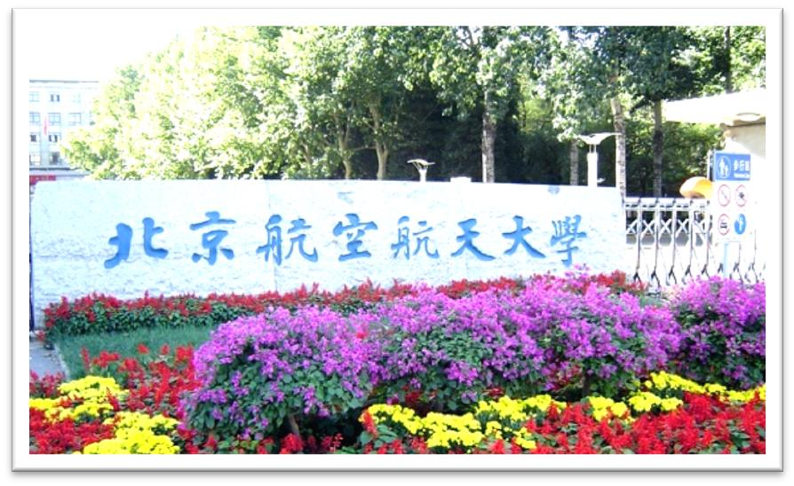Beijing University of Aeronautics and Astronautics

operation: work / activity / action rescue / relief / cleanup operation

For them this is a major operation which involves considerable planning. The patient will have / undergo an operation on appendicitis.

The doctor will do / perform / carry out an operation on the patient for appendicitis. He is an authority on surgery.

The salvage operation had proved (to be) a complete failure. The salvage operation had been a (complete) fiasco.

The salvage operation had been in vain.

The small ship, Elkor, which had been searching the Barents Sea for weeks, was on its way home.

The loss of the Titanic

The great ship, Titanic, sailed for New York from Southampton on April 10th, 1912. The Cutty Sark

One of the most famous sailing ships of the nineteenth century, the Cutty Sark, can still be seen at Greenwich.

The small ship, Elkor, *after she* had been searching the Barents Sea for weeks, was on its way home.

I have to be very careful not to offend the boss, who could fire me at any time.

I have to be very careful not to offend the boss, *because he* could fire me at any time. The action, which has aroused universal disapproval, is nevertheless the only solution.

The action, *although it* has aroused universal disapproval, is nevertheless the only solution. on one’s way (to …)

On his way to the sweet shop, he dropped his fifty pence and it bounced along the pavement and then disappeared down a drain.

造句：在 Ellesmere 公司工作的垃圾工 Alfred Bloggs，在连续工作了 8 小时之后，正在回家的途中。

… Alfred Bloggs who worked as a dustman for the Ellesmere Corporation. Some plays are so successful that they run for years on end.

Alfred Bloggs, a dustman for the Ellesmere Corporation, who had been working for 8 hours on end, was on his way home.

A radio message *from the mainland* had been received by the ship's captain instructing him to give up the search.

radio message radiogram telegram mainland Europe

mainland China

captain / skipper first mate sailor / seaman / mariner crew

She was carrying 1,316 passengers and a crew of 89l. Though the crew were at first under the impression that … instruct sb. to do ...

The editor at once sent the journalist a fax instructing him to find out the exact number of steps and the height of the wall.

Mrs. Ramsay was instructed to place the money in a cardboard box and to leave it outside her door.

abandon the search stop / cease the search abort the search

造句：老太太收到绑匪的一封信，命令她支付 1,000 英镑的赎金。

A letter from the kidnappers had been received by the old lady instructing her to pay a ransom of

￡1,000.

造句：考古学家作出了一个有趣的发现，一尊古代的女神像原来竟是 (turn out to be) 一位看上去很摩登的女郎 (a very modern-looking woman)。

An interesting discovery was made by archeologists that an ancient statue of a goddess turned

out to be a very modern-looking woman.

The captain knew that another attempt would be made later, for the sunken ship *he was trying to find* had been carrying a precious cargo of gold bullion.

make an attempt to do ...

The captain knew that his attempt would not be the only attempt. The captain knew that his attempt would not be the only one.

The captain knew that his would not be the only attempt. Our age is a tragic age.

Our age is a tragic one.

Ours is a tragic age. — Shakespeare



Brevity is beauty.

简洁即是美。

cargo freight

The ship carries both freight and passengers. cargo ship / airplane

freight train

The sea bed was scoured with powerful nets and there was tremendous excitement on board when a chest was raised from the bottom.

sea bed / sea floor / sea bottom tremendous adj. very great

In his day, Mendoza enjoyed tremendous popularity.

Though the new rudder was fitted at tremendous speed, it was impossible for the Cutty Sark to win.

The response to this competition was tremendous. on board / aboard

All ticketed passengers for Flight 1066 to Athens should now be on board. I get it!

I’m so excited about having Monica come on board with us.

His experience will be valuable to both of us. Welcome aboard, Malcolm!

... people on aboard were very excited ...

造句：消息传来时，演播室 (studio) 里的人们非常激动。

There was tremendous excitement in the studio when the news came.

造句：有越来越多的人对英语有兴趣。

There are more and more people who are interested in English.

There is growing interest in English.

造句：人们普遍同意妇女应该享有和男人完全的平等。

People generally agree that women should enjoy full equality with men. There is general agreement that women should enjoy full equality with men.

Though the crew were at first under the impression that the lost ship had been found, the contents of the chest proved them *wrong*.

be under the impression that ...

Sorry, I was under the impression that you were the manager. give sb. the impression that ...

The sudden movement of the door made it sway slightly and it gave me the impression that it was about to leap out at me.

be / live under the illusion / delusion that ...

Even he still lives under the illusion that country life is somehow superior to town life. The worst thing about the do-it-yourself game is that sometimes even men live under the delusion that they can do anything, even when they have repeatedly been proved wrong. **prove + 宾语 + 宾补**

The facts proved their worries unnecessary.

What they had in fact found was a ship *which had been sunk many years before*.

造句：哥伦布其实发现的不是印度，而是一个全新的大陆，在那里土著居民 (aborigine) 已经居住了 (inhabit) 两万多年了。

What Columbus had in fact found was not India but a new continent which had been inhabited by aborigines for over twenty thousand years.

There were books, clothing and photographs, together with letters which the seaman had once received from his wife.

clothes

Fine clothes make a man. clothing

Food, clothing, shelter and transportation are daily necessities. together with … = along with …

Peter was murdered, together / along with three guards.

These new facts, together / along with the other evidence, prove the prisoner's innocence. his men

The general ordered his men to fire.

In times of peace, when business was bad, Hawkwood and his men would march into a city-state and, …

subordinate

He left the routine check to one of his subordinates. superior

I’ll pass your complaint on to my superiors. counterpart

Chinese President Xi Jinping and his American counterpart Barack Obama will hold talks on Monday.

the grassroots

shipwreck

Poor man! — mentally a wreck.

Nothing *of value* was found, but the numerous items which were brought to the surface proved to be *of great interest*.

of + 名词 : 描述人或事物的特征

1、做后置定语。

nothing of value = nothing valuable

a matter of significance = a significant matter a ship of 46,000 tons

a man of wide social relations 2、在系动词后做表语。

... proved to be of great interest. = proved to be very interesting. It is of no use = it is useless.

Her dress is of dark crimson. He is of a peculiar disposition. a man of middle height

The man is of middle height.

a girl of remarkable imagination

The girl is of remarkable imagination. numerous / countless

There are countless people who, ever since their early years, have learned to associate snails with food.

From a heavy gun that was raised, the captain realized *that the ship must have been a cruiser*. from prep. 考虑到，从……来看/判断

From *her looks* I'd say she was Swedish.

From *what I heard* the company's in deep trouble.

From *this* the captain was able to piece together all the information that had come to light.

造句：从这些雕像的碎片来看，考古学家们明白了这座庙宇当初肯定是一个祭祀的场所。From the fragments of statues, the archaeologists realized that the temple must have been a place of worship.

In another chest, which contained the belongings of a ship's officer, there was an unfinished letter *which had been written on March 14th, 1943*.

... which was dated March 14th, 1943. date

a newspaper dated October 1st, 2005 a girl aged 20

a man named John

a novel entitled Three Kingdoms a movie starring Tom Hanks

The movie starred Tom Hanks

The captain learnt *from the letter* that the name of the lost ship was the Karen.

The most valuable find of all was the ship's log book, parts of which it was still possible *to read*.

“名词 + 介词 + 关系代词” 引导非限定性定语从句

造句：他有两个儿子，其中的一个死于战火。

He has two sons, one of whom died in the war.

造句：演讲者提了 (pose) 四个问题，它们的答案被证明非常具有启发性(illuminating)。

The speaker posed four questions, the answers to which proved very illuminating.

…, parts of which it was still possible *to read*.

..., parts of which were still possible *to read*.

Most of our fears are unreasonable, but they are impossible *to erase*. Most of our fears are unreasonable, but it is impossible *to erase them*.

…, but it was impossible *to stop the thieves*. √

…, but the thieves were impossible *to stop*. X He is impossible *to deal with*. √

..., parts of which could still be read.

..., parts of which were still legible.

From this the captain was able to piece together *all the information that had come to light*. piece sth. ↔ together

The police are still trying to piece together the facts. The archaeologists pieced the fragments together. reconstruct

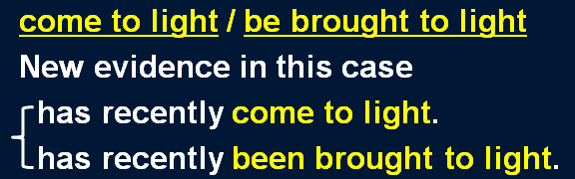When the archaeologists reconstructed the fragments, they were amazed to find that the goddess turned out to be a very modern-looking woman.

cast / shed / throw light on ...

These discoveries may cast some light on the origins of the universe.

Even seemingly insignificant remains can shed interesting light on the history of early man. The Karen had been sailing in a convoy to Russia when she was torpedoed by an enemy submarine.

主句（进行时 / be about to do）+ when ... “when”应译为“这时”或“突然”

I *was having* dinner when the phone rang. I *was about to leave* when the phone rang.

He *was going* to the sweet shop when he dropped his fifty pence.

He *was* still *mumbling* something about hospitals at the end of the party when he slipped on a piece of ice and broke his left leg.

The idea never appealed to me very much, but one day, after a heavy shower, I happened to *be walking* in my garden when I noticed a huge number of snails taking a stroll on some of my prize plants.

The morning passed rapidly and Frank *was about to leave* when he noticed a large packing case lying on the floor.

This was later confirmed by *a naval official at the Ministry of Defence* after the Elkor had returned home.

All the items that were found were sent to the War Museum.